**Front Controller**

While trying to study the Application Control Pattern I kept running into the Front Controller Pattern. So I wanted to explain and show what Front Controller Pattern is.

**Front Controller**

*A controller that handles all requests for a Web site.*

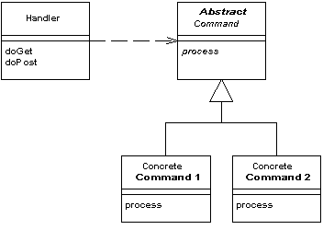

In a complex Web site there are many similar things you need to do when handling a request. These things include security, internationalization, and providing particular views for certain users. If the input controller behavior is scattered across multiple objects, much of this behavior can end up duplicated. Also, it's difficult to change behavior at runtime.

The Front Controller consolidates all request handling by channeling requests through a single handler object. This object can carry out common behavior, which can be modified at runtime with decorators. The handler then dispatches to command objects for behavior particular to a request.

The front controller may be implemented as a Java object, or as a script in a script language like PHP, Python or Ruby that is called on every request of a web session. This script, for example an index.php, would handle all tasks that are common to the application or the framework, such as session handling, caching, and input filtering. Based on the specific request, it would then instantiate further objects and call methods to handle the particular task required.